# 4B Nationalism Recitation

**Role Playing:**

**Instructions: The entire group must come together (terrific pun for nationalism week) to compose a speech. One particular person will deliver it. The rest of the gp members will pretend to be the press corps and ask “important questions” which the character will wonderfully be able to answer without hesitation.**

**Gp 1: You are the teacher in the “Last Lesson.”** **Write s short speech (100 words) telling your students the importance of patriotism.**

* In the short story “The Last Lesson” (1873), appeals to nationalism are obvious. Which aspects of nationalism were Alphonse Daudet appealing to? Explain your answer.
* How is Daudet’s idealism complemented by Edmondo De Amicis’s *Heart of the Boy* (1883)?

**Gp 2: You are Mazzini. Write s short speech (100 words) telling your students the importance of your brand of nationalism.**

* What evidences can you find in Mazzini’s essay (1844) that it was appealing to universal liberal values?
  + - Background: "Giuseppe Mazzini." Encyclopædia Britannica. Encyclopædia Britannica Online Academic Edition. Encyclopædia Britannica Inc., 2013. Web. 04 Sep. 2013. <http://www.britannica.com/EBchecked/topic/371294/Giuseppe-Mazzini>.
* According to Mazzini, what are the limitations of Liberalism?
* How does Mazzini define a "country" or "nation"?
* Why does he stress "duties" rather than "rights"?
* How does nationalism redress the problems that Liberalism fails to solve?
* Would you consider Mazzini to be a Liberal in addition to being a Nationalist?

**Gp 3: Presentation: Ray Taras (2008), “Nationalism and Conflict.”**

**Gp 4: You are Renan. Write s short speech (100 words) telling your students your vision of nationalism & the dangers of unbridled nationalism.**

* How are Renan’s arguments different from Mazzini’s proposals? What is the significance of the differences?
* When Renan speaks of ‘the fusion of the populations’ what is he really talking about? (pg 2).
* How far can one agree with Renan’s recommendation that the‘will to live together’ is a significant condition for the creation of a nation?

**Gp 5. You are Hume. Write s short speech (100 words) telling your students your version of “National Character.”**

* **David Hume, "Of National Characters," in Essays, Moral, Political, and Literary (1742).**

* Clearly countries such as Singapore do not have a rich legacy, can Singapore be legitimate in Renan’s eyes? Does Singapore qualify in Hume’s eyes to have a National Character?

# Ernest Renan – Context

Lecture at the Sorbonne in Paris on the question ‘what is a nation?’;

speaking 12 years after the Franco-Prussian war, which resulted in the French loss of Alsace-Lorraine, claimed by German nationalists because of its largely German-speaking population.

His lecture constituted a revolt against the centralized authority of modernizing industrial states.

According to this purely voluntaristic definition, a nation is any group of people aspiring to a common political state-like organization. If such a group of people succeeds in forming a state, the loyalties of the group members would be “civic” (as opposed to “ethnic”) in nature.

Gave a critique of what he called ‘ethnographic’ definitions of nationhood which normally define national boundaries on the basis of putatively objective commonalities of race, language, or culture.

**Main Arguments – subjective phenomenon**

Metaphysics of the origin of the nation, he argued that nationhood was at its core a *subjective* phenomenon, founded on the ‘will to live together’.

“A nation is a soul, a spiritual principal”.He fully recognized the spiritual component necessary in the recipe for a nation. “No, it is not the soil any more than the race which makes a nation. The soil provides the substratum, the field for struggle and labour: Man provides the soul”.

A nation is truly expressed by its inhabitants. Present-day consent, the desire to live together, the will to perpetuate the value of the heritage that one has received in an undivided form". "avoir fait de grandes choses ensemble, vouloir en faire encore" (having done great things together and wishing to do more).

**A rich legacy of memories.**

Nations are the culmination of long past of endeavours, sacrifice and devotion – “a grand solidarity” constituted by the sentiment of sacrifices which have been made in the past and those that one is disposed to make again. – “A nation is therefore a large-scale solidarity, constituted by the feeling of the sacrifices that one has made in the past and of those that one is prepared to make in the future". It renews itself especially in the present by a tangible deed, the approval, the desire, clearly expressed, to continue the communal life. One Metaphor he used: he characterized the nation as an ‘everyday plebiscite’.

The modern nation is a historical result brought about by a series of convergent facts and it is NOT defined by: race, language, religion, communal interests or geography. (However, in latter parts he does cite geography as a significant factor.) Most nations began as dynasties. According to Renan, dynastic territories progress to nations in one of three ways: dynastic unions, general popular consciousness and direct will of provinces

Nations are the harbingers of liberty where every citizen enjoys the freedom of speech, equality and also redress the rights provided. A nation carefully directs the humanity towards a healthy progression.

Renan’s definition encourages us to treat nations as entities – a substantial entity of some kind, though perhaps one that is elusive and difficult to define.

Heavily influenced Benedict Anderson’s concept of “Imagined Communities” (1983).

# 19th Century Italian Unification Movement – Context

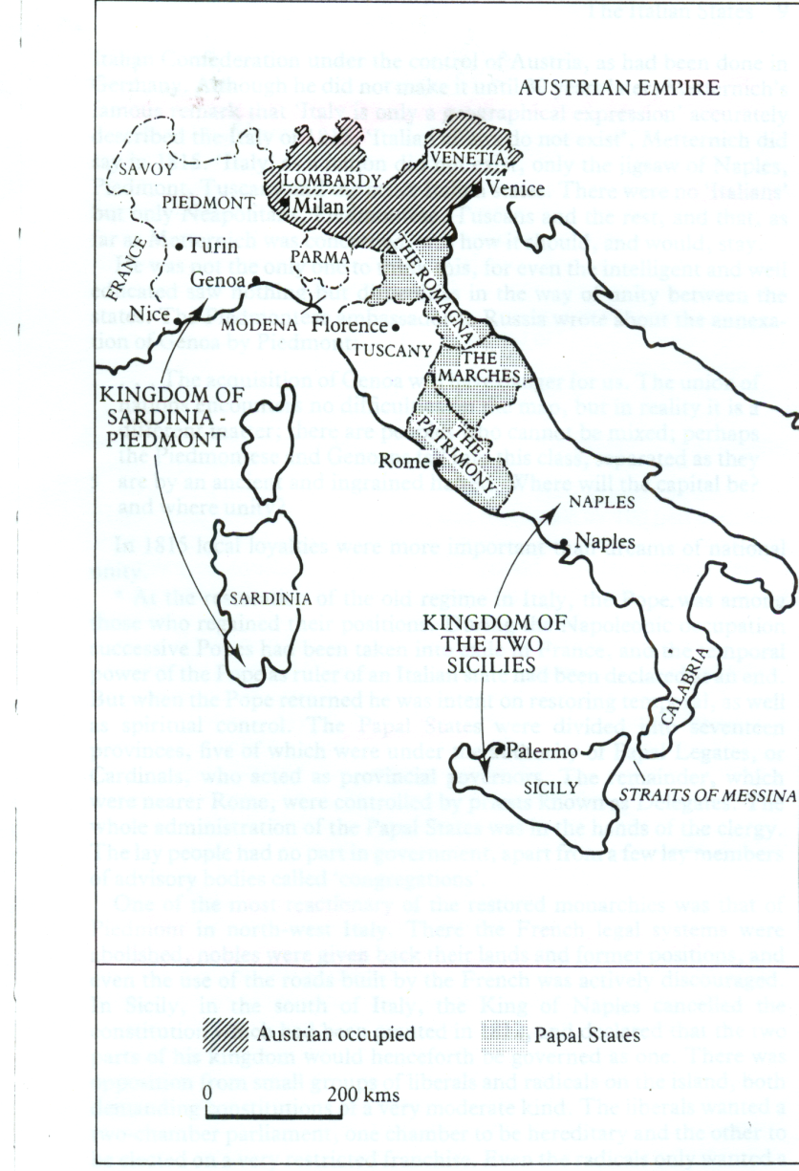Napoleon's creation of a Puppet Kingdom of Italy

Stimulated movt for Italian unification on part of intellectuals & middle class

19th c saw 3 major independent states in Italy: a. Kingdom of 2 Sicilies; b. Kingdom of Sardinia, (1) island of Sardinia & mainland area of Piedmont; c. Papal states

other areas such as Tuscany, Lombardy & Venetia controlled by Austrian Empire

Rome was the center of the peninsula both spiritually & geographically

After the Battle of Waterloo in 1815 (Napoleon’s defeat), the Congress of Vienna was determined to ensure that Austria could control Italy; its main duty was to prevent a French revival and keep the French out of northern Italy; revolts of 1820's, 30's, & 1848 effectively suppressed by superior force of arms by Austrians

**Giuseppe Mazzini (1805-72) <Mott-zini>**

born in Genoa in 1805; republicanism and nationalism were rife; his degree was in law but he was more interested in literature

intelligent, sensitive and physically frail; suffered greatly from depression; wore only black from time he was 15. Mazzini was an impractical businessman, but his character kept people spell bound; captivated women by the hundreds

lived life as a revolutionary agitator; spent most of his life in exile in London; Impressed his followers thru his impassioned writings ; influence extended throughout Europe; he sent propaganda literature into Italian ports hidden in cargoes of stones and grains

Exiled from Genoa for his membership in a secret & violent organization – based in Marseilles, France; he founded Young Italy movement(1) members all under 40

**Mazzini’s ideas**

Never wrote a systematic treatise on his ideas; were often unoriginal. For his fellow countrymen, unfortunately, his derivative ideas were deemed too novel and abstract for any mass appeal; Pensiero ed Azione (Thought and Action) was his motto, but was accused of being all talk and no action; Marx called him Theopompus; was tormented by his failures as a man of action

wanted a free, independent, democratic, republican and united Italy; supported a unitary state (strong central govt); was opposed to federalist (central govt control some functions such as defence) or confederalist (extremely loose) proposals. Did originally asking the Piedmont King Charles Albert and Pope Pius to lead the Italian unification movement but changed his mind later

argued that Italy needed to be unified with the aid of the masses through revolutionary action; believed that the masses were willing to die for freedom; knew very little about Italy hence tended to exaggerate the possibility of the masses play the central role; was over-optimistic that the people would rise up against tyranny on their own initiative; ‘fare da se’ (go it alone); believed that Italy could became united with her own efforts; was opposed to seeking help from France

was supportive of all European nationalist groups; believed that states based on national divisions and democratic institutions would not go to war but proceed to a higher unity; wanted a United States of Europe but was vague how the political map of Europe would be changed

was seen as an autocratic democrat; invoked God and his conscience as his sole authority; felt that the Roman Catholic church had deviated from its origins and opposed the clergy and their beliefs; argued that unification was a religious duty sanctioned by God; felt that the spirit of religion must dominate the new Italy and Europe;

considered the individual and nation were equally sacred; stressed that the duties of men were more important than their rights; was a pioneer in calling for social security, women’s liberation and suffrage reform

was opposed to Marxism; did not attack right to wealth and property; felt that communism would prove to be equally oppressive

**His main contribution**

Known as "Soul of Italy" – spiritual inspiration for Italian unification. He became leading prophet of the Risorgimento (the Resurgence) – movement for Italian unification; they wanted to restore nation to glorious days of Roman & Renaissance times

was to inspire in others the same enthusiasm for his cause; his achievement was in defining the goal for the nationalists and arousing enthusiasm; his biggest flaw was his romantic idealism and his inability to compromise; finally died in 1872; disillusioned that the last 20 years of his life he possessed little influence; his intense dedication & visionary ideas were to be fulfilled by another generation of Italian patriots